HW_5_Extra Credit Completed Item List
- Updated input variables so that T = 256 istead of T = 1000
- Added the “sack” variable to chickens
- Updated the “CountCrowns()” function to update the sack component after each tournament
- Created the ShareObservations() and tested that it functions correctly
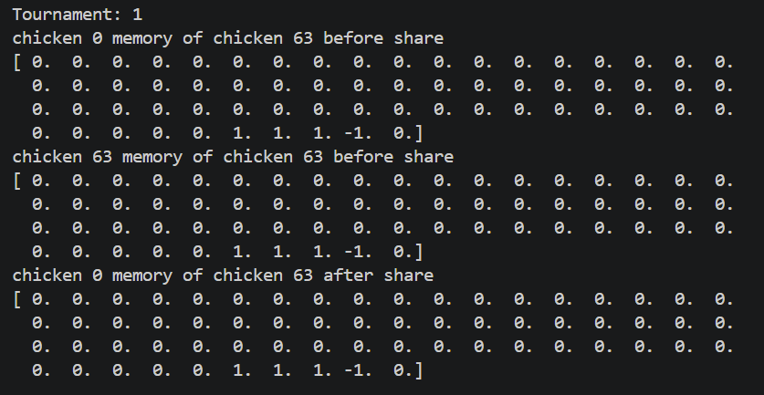
- Created transfercrowns() and tested that it functions correctly
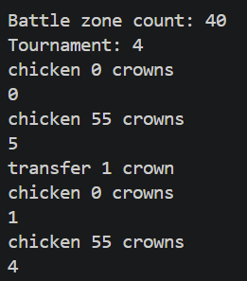
- Created ExtendSackOwnership() and tested that it functions correctly
